Important update

This next project uses Bootstrap version 3. Since recording, Bootstrap has released version 4 with some differences.

If you want to follow along exactly as we do in the course. you can still choose v3 from the navigation menu of the Bootstrap home page:

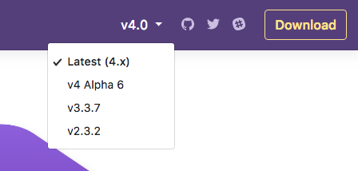

Then follow along as usual.